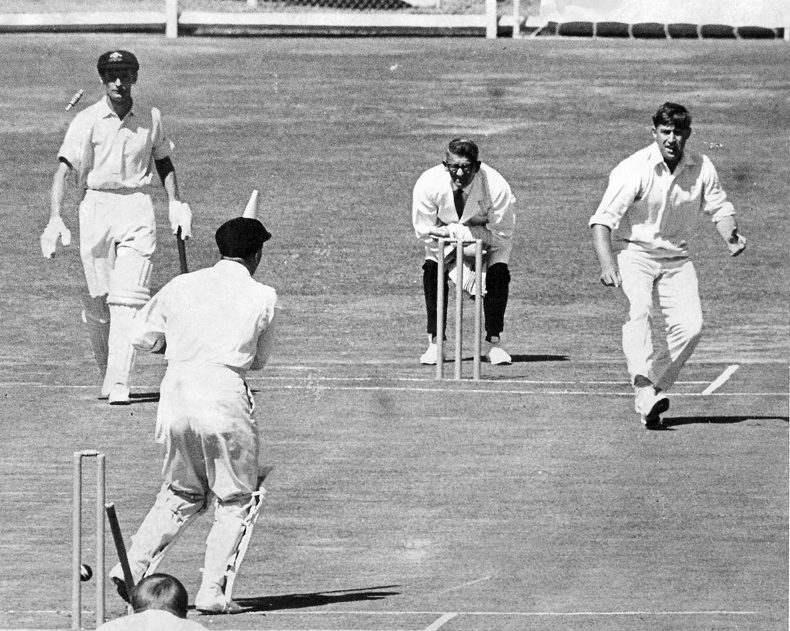

**RC Motz bowls LE Flavell third ball of the match, BC Booth the non striker. Lancaster Park 17 February 1967**

**Australia 279 and 156 Canterbury 256 and 180/6. Canterbury won by four wickets.**